

LAB NO.

**____5___**

|  |  |
| --- | --- |
| TASK NO | OBJECTIVE |
| 1 | Using the Shopping List files from the previous videos update the shopping list app to do the following: A. If you click on the list item, it toggles the .done  class on and off. B. Add buttons next to each list item to delete the item when clicked on its corresponding delete button. C. BONUS: When adding a new list item, it automatically adds the delete button next to it (*hint: be sure to check if new items are clickable too!*) |
| 2 | Write a JavaScript program to calculate the volume of a sphere. |
| 3 | Create a webpage that perform any of the following operations. |
| 4 | Create a document with multiple tabs with background color. Upon hover background color of the document is changed accordingly |

Submitted On:

-4-22

**TASK 1:**

**CODE:**

HTML:

<body>

    <div id="myDIV" class="header">

        <h2>Humza's To Do List</h2>

        <input type="text" id="myInput" placeholder="Title...">

        <span onclick="newElement()" class="addBtn">Add</span>

      </div>

      <ul id="myUL">

        <li>Hit the gym</li>

        <li class="checked">Pay bills</li>

        <li>Meet George</li>

        <li>Buy eggs</li>

        <li>Organize office</li>

      </ul>

    <script src="script1.js"></script>

</body>

JS:

var myNodelist = document.getElementsByTagName("LI");

var i;

for (i = 0; i < myNodelist.length; i++) {

  var span = document.createElement("SPAN");

  var txt = document.createTextNode("\u00D7");

  span.className = "close";

  span.appendChild(txt);

  myNodelist[i].appendChild(span);

}

var close = document.getElementsByClassName("close");

var i;

for (i = 0; i < close.length; i++) {

  close[i].onclick = function() {

    var div = this.parentElement;

    div.style.display = "none";

  }

}

var list = document.querySelector('ul');

list.addEventListener('click', function(ev) {

  if (ev.target.tagName === 'LI') {

    ev.target.classList.toggle('checked');

  }

}, false);

function newElement() {

  var li = document.createElement("li");

  var inputValue = document.getElementById("myInput").value;

  var t = document.createTextNode(inputValue);

  li.appendChild(t);

  if (inputValue === '') {

    alert("You must write something!");

  } else {

    document.getElementById("myUL").appendChild(li);

  }

  document.getElementById("myInput").value = "";

  var span = document.createElement("SPAN");

  var txt = document.createTextNode("\u00D7");

  span.className = "close";

  span.appendChild(txt);

  li.appendChild(span);

  for (i = 0; i < close.length; i++) {

    close[i].onclick = function() {

      var div = this.parentElement;

      div.style.display = "none";

    }

  }

}

**OUTPUT:**

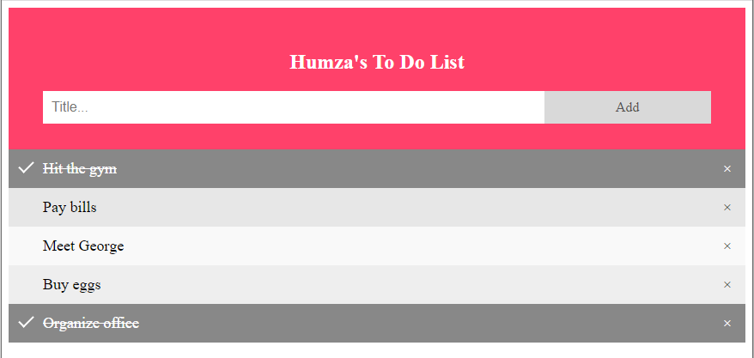

**TASK 2:**

**CODE:**

HTML:

<div class="box">

    <p>Input radius value and get the volume of the sphere.</p>

    <form method="post" id="VolumeForm">

        <label for="radius">Radius</label><input type="text" name="radius" id="radius" required>

        <label for="volume">Volume</label><input type="text" name="volume" id="volume" readonly>

        <input type="submit" value="Calculate" id="submit">

    </form>

   </div>

JS:

<script>

        function volume()

        {

            var volume;

            var radius = document.getElementById('radius').value;

            radius = Math.abs(radius);

            volume = (4/3) * Math.PI * Math.pow(radius, 3);

            volume = volume.toFixed(2);

            document.getElementById('volume').value = volume;

            return false;

        }

window.onload = document.getElementById('VolumeForm').onsubmit = volume;

    </script>

**OUTPUT:**

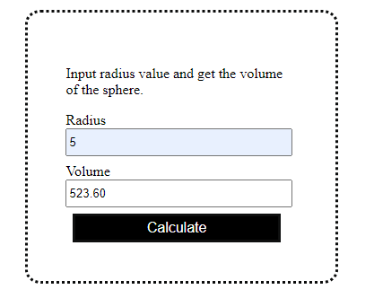

**TASK 3:**

**CODE:**

HTML:

 <div class="square">

    <h2>Select any one option:</h2>

    <input class="button" type="button" value="Generate Table" id="table">

    <input class="button" type="button" value="Calculate Power" id="power">

    <input class="button" type="button" value="Generate Sequence" id="sequence">

    <input class="button" type="button" value="Generate Odd No. / Even No." id="evenOdd">

   </div>

   <div class="square" style="padding: 1% 2%;" >

       <p id="final"> </p>

   </div>

JS:

<script>

        function generateTable()

        {

            var table = '';

            var number = parseInt(prompt('Enter Number to Generate Table of: '));

            for(let i = 1; i <= 10; i++) {

                const final = i * number;

                table += `${number} * ${("0" + i).slice(-2)} = ${("0" + final).slice(-2)}` + '\n';

            }

            document.getElementById('result').innerText = table;

        }

        function calculatePower()

        {

            var power = '';

            var base = parseInt(prompt('Enter the Value of Base: '));

            var exponent = parseInt(prompt('Enter the Value of Exponent: '));

            let final = Math.pow(base, exponent);

            power += `${base} ^ ${(exponent)} = ${(final)}`;

            document.getElementById('final').innerText = power;

        }

        function generateSequence()

        {

            let sequence = '{ ';

            var limit = parseInt(prompt('Enter limit to Generate Sequence up to: '));

            for(let i = 0; i <= limit; i++) {

                if (i==limit){

                    sequence += `${(i)} `;

                }

                else{

                    sequence += `${(i)} , `;

                }

            }

            sequence += '}'

            document.getElementById('final').innerText = sequence;

        }

        function generateEvenOdd()

        {

            let sequence;

            let type = prompt('Enter "O" for Odd and "E" for Even Sequence Generation: ');

            if (type.toLowerCase() === 'o'){

                sequence = '{ '

                for(let i = 1; i <= 20; i += 2) {

                    if (i==20){

                        sequence += `${(i)} `;

                    }

                    else{

                        sequence += `${(i)} , `;

                    }

                }

                sequence += '}'

            }

            else if (type.toLowerCase() === 'e'){

                sequence = '{ '

                for(let i = 0; i <= 20; i += 2) {

                    if (i==20){

                        sequence += `${(i)} `;

                    }

                    else{

                        sequence += `${(i)} , `;

                    }

                }

                sequence += '}'

            }

            else{

                sequence = 'Invalid Input'

            }

            document.getElementById('final').innerText = sequence;

        }

        window.onload = document.getElementById('table').onclick = generateTable;

        window.onload = document.getElementById('power').onclick = calculatePower;

        window.onload = document.getElementById('sequence').onclick = generateSequence;

        window.onload = document.getElementById('evenOdd').onclick = generateEvenOdd;

    </script>

**OUTPUT:**

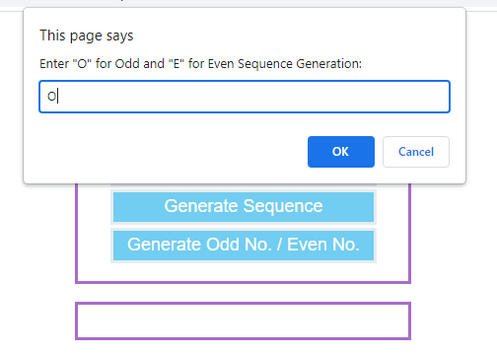

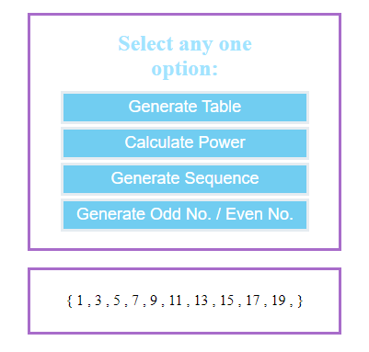

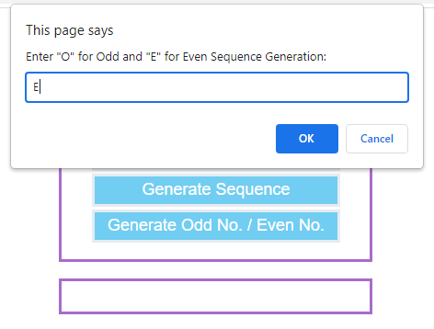

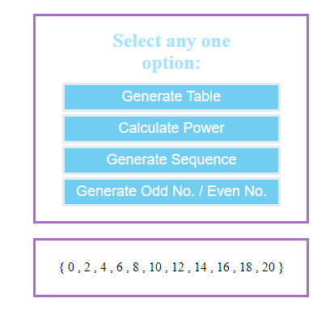

**TASK 4:**

**CODE:**

HTML:

<ul style="display: flex; justify-content: center;" type="none">

        <li class="tab tab-r" onmouseover="red()" onmouseleave="blank()">R</li>

        <li class="tab tab-o" onmouseover="orange()" onmouseleave="blank()">O</li>

        <li class="tab tab-y" onmouseover="yellow()" onmouseleave="blank()">Y</li>

        <li class="tab tab-g" onmouseover="green()" onmouseleave="blank()">G</li>

        <li class="tab tab-b" onmouseover="blue()" onmouseleave="blank()">B</li>

        <li class="tab tab-i" onmouseover="indigo()" onmouseleave="blank()">I</li>

        <li class="tab tab-v" onmouseover="violet()" onmouseleave="blank()">V</li>

    </ul>

JS:

<script>

       function red(){ document.body.style.background = "rgb(255, 102, 99)"; }

       function orange(){ document.body.style.background = "rgb(254, 177, 68)"; }

       function yellow(){ document.body.style.background = "rgb(253, 253, 151)"; }

       function green(){ document.body.style.background = "rgb(158, 224, 158)"; }

       function blue(){ document.body.style.background = "rgb(158, 193, 207)"; }

       function indigo(){ document.body.style.background = "rgb(204, 153, 201)"; }

       function violet(){ document.body.style.background = "rgb(251, 185, 197)"; }

       function blank(){ document.body.style.background = "white"; }

    </script>

**OUTPUT:**

